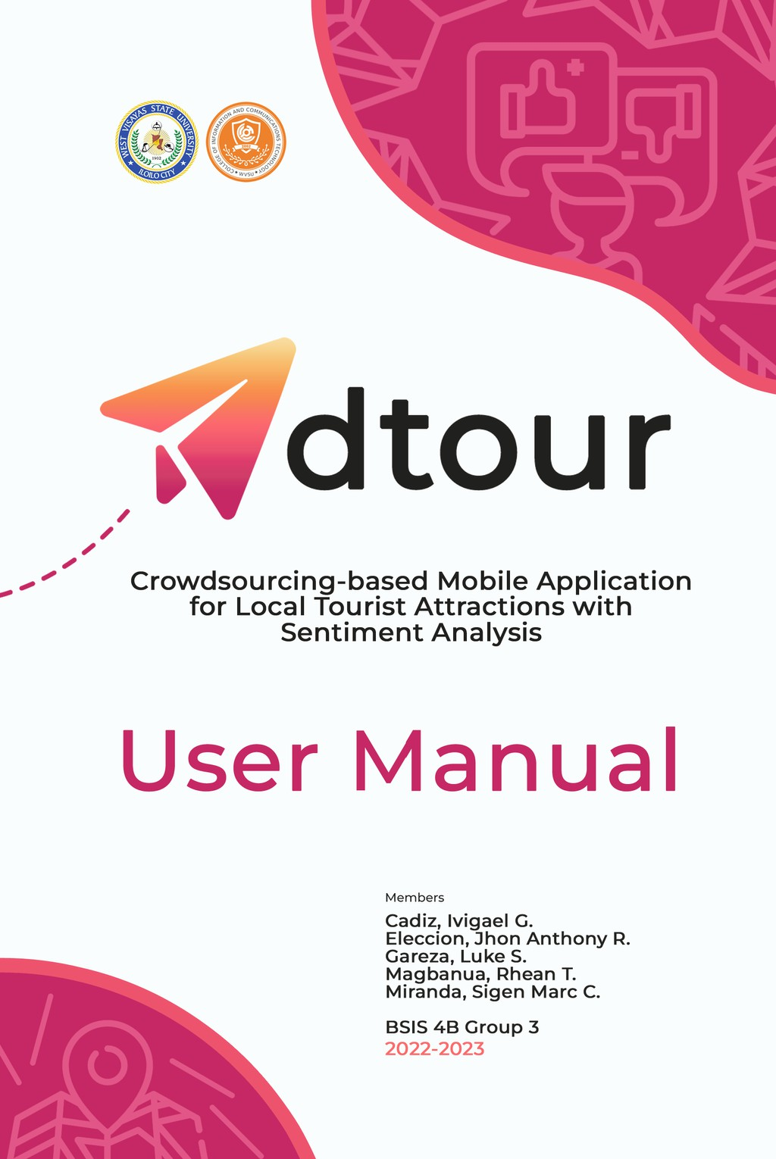

Crowdsourced-based Mobile Application with
Sentiment Analysis for Local Tourist Attractions

An Undergraduate Thesis
Presented to the Faculty of the
College of Information and Communications Technology
West Visayas State University
La Paz, Iloilo City

In Partial Fulfillment
of the Requirements for the Degree
Bachelor of Science in Information Systems

by
Iviegel G. Cadiz
Jhon Anthony R. Eleccion
Luke S. Gareza Rhean T. Magbanua Sigen Marc C. Miranda

May 2023


Disclaimer
User Manual

This software project and its corresponding documentation entitled “Crowdsourced-based Mobile Application with Sentiment Analysis for Local Tourist Attractions” is submitted to the College of Information and Communications Technology, West Visayas State University, in partial fulfillment of the requirements for the degree, Information Systems. It is the product of our own work, except were indicated text.

We hereby grant the College of Information and Communications Technology permission to freely use, publish in local or international journal/conferences, reproduce, or distribute publicly the paper and electronic copies of this software project and its corresponding documentation in whole or in part, provided that we are acknowledged.

Iviegel G. Cadiz
Jhon Anthony R. Eleccion Luke S. Gareza Rhean T. Magbanua
Sigen Marc C. Miranda

May 2023

1

User Manual

Table of Contents

1.0 Getting Started
1.1 Introduction
1.2 System Requirements
1.2.1 Hardware Specifications
1.2.2 Software Specifications
1.3 Installation
2.0 Using the System
2.1 Mobile Application
2.2 Web Application
2.3 Troubleshooting
2.4 FAQs (Frequently Asked Questions)
3.0 Contact Details

2

1.0 Getting Started
User Manual
1.1 Introduction

Derived from the Hiligaynon/Ilonggo word, ádto means “it is there” or in some Panay Island provinces, it also means “let’s go there” combined with an English term, tour means “a journey for pleasure in which several different places are visited.”

The Adtour mobile application guides tourists in Iloilo City to notable tourist attractions with the aid of crowdsourced information from other tourists. To make it easier for tourists to access at a glance, this crowdsourced information will be classified as positive (green) or negative (red). It also includes a map feature to navigate tourist attractions and determine the nearest attraction based on the user’s location with the check-in feature.

3
User Manual

1.2. System
Requirements

Certain requirements and specifications are necessary for the system to
be employed and agreed upon. These specific requirements must be observed to avoid unnecessary effects that may be encountered. In the following sections, the software and hardware specifications are presented.

1.2.1 Hardware
Specifications

In the hardware necessities, the researchers used and tested the mobile application with an Android 8.1.0 version of the operating system, an Octa-core processor, 3.00GB of RAM, and a 32.0 GB device storage. For system admin, the researchers tested the application on a desktop with Intel(R) Core (™) i5-3230M CPU @ 2.60GHz, 4GB RAM, and
64-bit operating system.

4
1.2.2. Software
User Manual
Specifications

The proposed system has certain software requirements that would ensure the systems accurate processing for it to work properly and employ the systems functionalities and to be in service. The software specifications describe the requirements of the developed system with relation to the software.

The system was developed using Visual Studio Code version 1.72.0 (user setup) with Dart version v3.50.0, Flutter v3.50.0. The VS Code is a source-code editor made by Microsoft with the Electron Framework, for Windows, Linux and macOS. Features include support for debugging, syntax highlighting, intelligent code completion, snippets, code refactoring, and embedded Git. It helps the programmer write code, helps in debugging and corrects the code using the intelli-sense method. In normal terms, it facilitates users to write the code in an easy manner. Its features let the user modify the editor as per the usage, which means the user is able to download the libraries from the internet and integrate it with the code as per his requirements.

Dart is a programming language designed for client development, such as for the web and mobile apps. It is developed by Google and can also be used to build server and desktop applications. It is an object-oriented, class-based, garbage-collected language with C-style syntax.

Flutter is a free and open-source UI framework for creating native mobile applications from Google. Released in 2017, Flutter allows developers to build mobile applications with a single codebase and programming language. This capability makes building both iOS and Android apps simpler and faster.

The mobile application requires Internet connectivity to function including a permission for location access. The mobile app is compatible with Android devices running in Android 6 and above.

The system admin was developed using Simple React Snippets v1.2.7. The
system can run on any updated browsers. React. js, more commonly known as React, is a free, open-source JavaScript library. It works best to build user interfaces by combining sections of code (components) into full websites. Originally built by Facebook, Meta and the open-source community now
maintain it. 5

1.3. Installation of
Mobile Application

a. Download the Adtour .apk file at:
https://bit.ly/WVSUCICT-AdtourAPK

b. Afterdownloading, open your phone settings and under security
tab, allow the "Install applications from unknown sources". c. Proceed to install the .apk file.

1.4. Configuration of Web Application

a. Download the package via Github at
https://bit.ly/WVSUCICT-Adtour
and download ZIP.
User Manual

b. Extract the folder.

c. After downloading, open the whole folder and load it through
Visual Studio Code.

c. Proceed to Terminal function, and type 'npm run'

d. The web application will start in your local browser afterwards.

6

2.0 Using the System
User Manual

2.1 Mobile Application

a. Install the APK and fill out necessary information

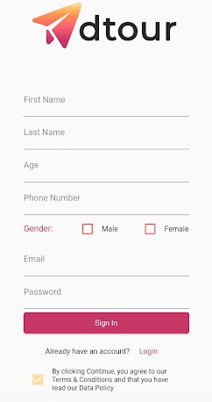

7
User Manual

b. Fill-out the tourist demographic information.

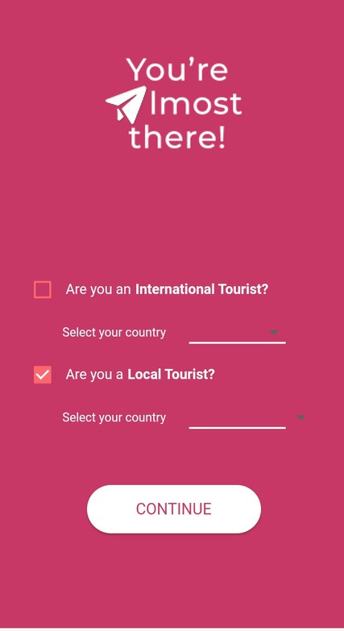

8

c. Log-in Screen Interface shows the sign-in screen of the mobile
User Manual
application.

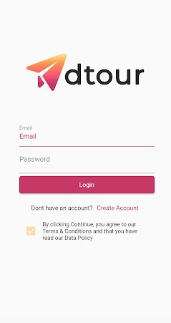

9
d. Profile Interface shows the profile interface of the mobile application wherein the user can choose to submit a photo from the gallery or the camera.
User Manual

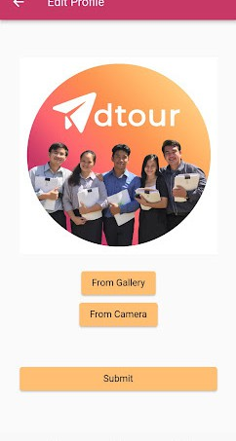

10
e. Click the check-in button for the nearest attraction and turn on your
User Manual
location.

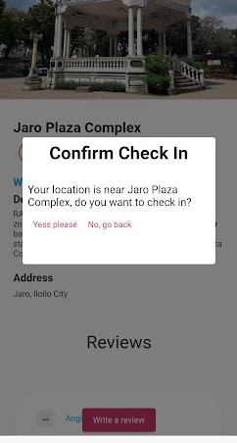

11
User Manual

f. If confirmed, you may submit feedback or the crowdsourced
information. Once submitted successfully, the feedback will be part of the tourist attraction profile.

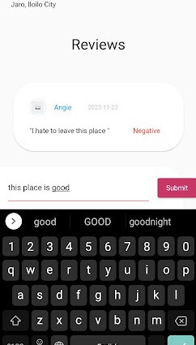

12
g. In order to see the submitted feedback, visit the tourist attraction profile and check if your submitted feedback is positive or negative.
User Manual

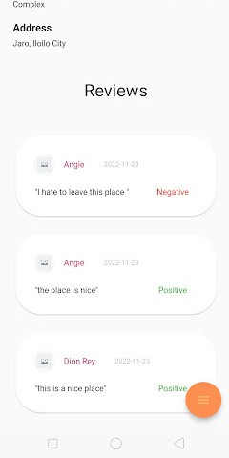

13
User Manual

h. Visit other tourist attractions and click the check-in button to determine
the nearest location. You may submit another feedback afterwards.

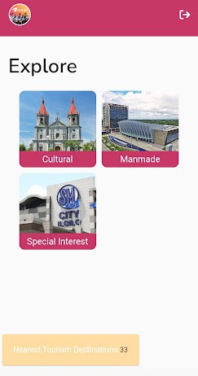

14
i. If you are lost or in case you need to find where a tourist attraction is located, you can use the map button in the lower right side of the tourist attraction profile.
User Manual

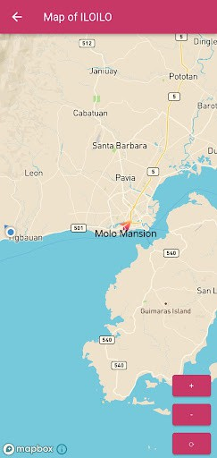

15
j. You may log-out or log-in again if you want to use the app for another day of visit in some attractions of Iloilo. And yes! Your account is saved as data.
User Manual

16
2.2 Web Application
User Manual

a. Log-in as Admin

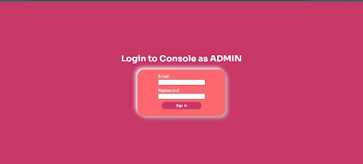

b. Explore the overview page combined with Quantitative and
Qualitative information.

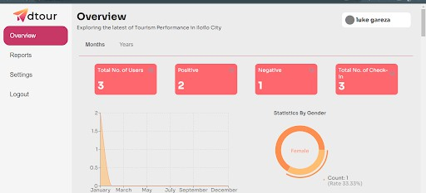

17
c. Choose your preferred analytics report and generate it into PDF.
User Manual

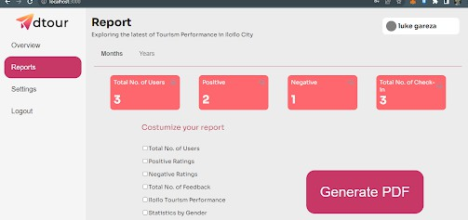

d. Manage users and manage these sites by adding new tourist attractions.

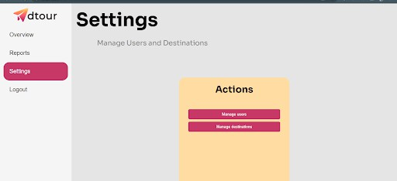

18

2.3 Troubleshooting
User Manual

Sentiment Analysis accuracy rate

The application was trained using Google Colab to generate better
accuracy for our sentiment analysis because the default dataset that the text classification had was about movies, so we gathered data from the internet about hotel reviews and museum reviews, combined and cleaned the data using Power Queries, and replaced the old data set
with the one that we trained.

19
User Manual

2.4. FAQs

1. Where will be our data stored?

The mobile application uses Firebase database to store and sync data between users in real-time.

2. Is the application available for IOS?

Unfortunately, no. The Adtour mobile application is only available for the Android operating system.

3. Is Adtour free to download?

Yes, the application is free to use and available to everyone who meets the system specifications.

4. Do I need the internet inorder to use the app?

Yes, both mobile and web applications require internet connectivity to function including a permission for location access.

5. Where will be our data stored?

The mobile application uses Firebase database to store and sync data between users in real-time.

20
3.0 Contact Details
User Manual

Researcher & Software Architect Assistant
Iviegel G. Cadiz

ivigael.cadiz@wvsu.edu.ph

Technical Editor & Software Tester
Jhon Anthony R. Eleccion

jhonanthony.eleccion@wvsu.edu.ph

Software Developer & QA Engineer
Luke S. Gareza

luke.gareza@wvsu.edu.ph

Software Architect
Rhean T. Magbanua

rhean.magbanua@wvsu.edu.ph

Project Manager & UI/UX Designer
Sigen Marc C. Miranda

sigenmarc.miranda@wvsu.edu.ph

Thesis Adviser
Shem Durst Elijah B. Sandig

sdesandig@wvsu.edu.ph
21


